School of Sanctuary Renewal 2022
‘The school is a welcoming and inclusive community. Pupils and staff recognise and celebrate the diversity present in the school and wider community. The care, support and guidance offered by the school have a notable impact on pupils’ ambitions and the progress that they make.’ Estyn Report p.8
Pentrehafod School renewed our School of Sanctuary status in June 2022. We demonstrated how we keep up-to-date with learning about supporting those families who are seeking sanctuary in Wales. As a school, teachers participate in the B.A.M.E Ed forum and have attended training from DARPLE and RVE Natre. Students have also been involved in The World Reimagined Project.
We continue to embed understanding of migration issues within the curriculum. The Humanities department provides learning about migration and the push and pull factors. The English department incorporate discussion around the theme of seeking sanctuary reading literature based on these topics. Students have created their own poetry and speeches related to seeking sanctuary. The art department, prior to the World Reimagined project, researched and created artwork related to those seeking sanctuary.

We continue to update and develop specific policies to help support new arrivals from outside the UK to our school. We have policies for Minority Ethnic Learners, and Welcoming EAL and AS learners to Pentrehafod (see our policies).
Students in school participated in the Swansea School of Sanctuary Logo design competition. Four winners from our school worked with six other schools to create and develop a logo for schools who have been awarded School of Sanctuary Status in Swansea.
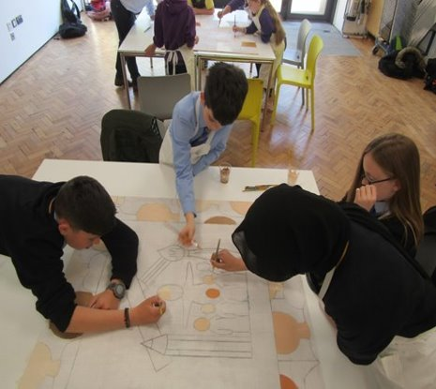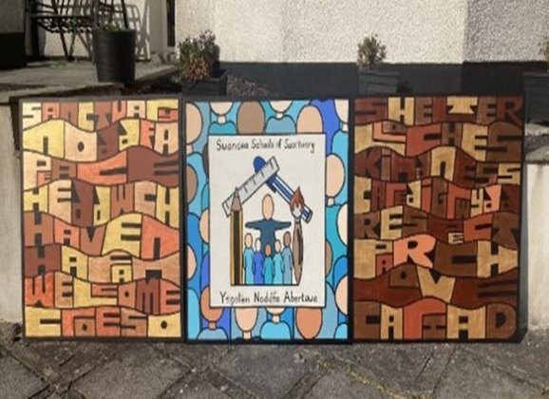
Some of our Young Interpreters and prefects took the initiative to promote food and clothing collections for Ukrainian refugees in March 2022.
We ensure that our environment reflects the linguistic repertoire of our school.
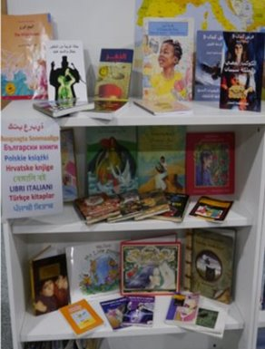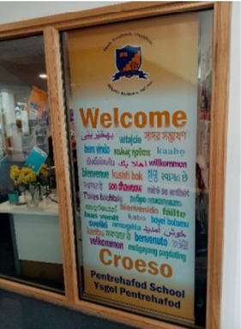

It is important that we share School of Sanctuary status with other schools and the wider public. We attend the School of Sanctuary Group in Swansea and share our progress on social media.

