22nd June 23

Dear Parent/Carer
Important changes to School Meals/Trips Online Payments September 2023
Our online payment provider for school meals and trips is changing from September 2023. We will no longer be using sQuid, and the new provider will be CRB Cunningham’s.
We advise that you run the balances down before the end of term, as school meal accounts will start from a ‘fresh’ £0.00 balance in September.
Next steps:
1. Use up balance: Please ensure any remaining balance on sQuid is used up before the end term. If you are still in credit on your sQuid account at the end of term, then you will need to request a refund from sQuid directly.
2. Parent account registration: Onboarding information will be provided to parents/carers by the end of the school term, to allow you to set up the account and load funds in preparation for September.
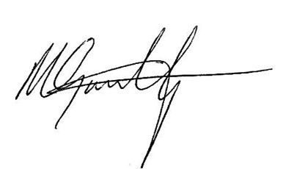
Yours faithfully,

Mr M Goulding
Headteacher

